**MAKER’S LAB**

**By Kids In Design**

www.kidsindesign.com

**Spring semester 2025, Lower Lab (on-site)**

**MONDAYS, K-3 grade**

Calling all inventors, tinkerers and out-of-the-box thinkers! In our maker space we will be fostering the inventive and imaginative thinking that produces remarkable engineers, inventors, and other movers and shakers. We will reinvent and redesign familiar objects (think park benches, lamps, hats, costumes, and even wheels!), while learning the basics of design, modelling the spaces and volumes that contain the human body, developing empathy as a designer, and exploring new fields and interests. We will build and create hands-on projects in every class.

Kids In Design program has partnered with other top NYC schools such as Spence, PS6, Nest +M, Allen Stevenson, Dwight, Avenues, and many others.

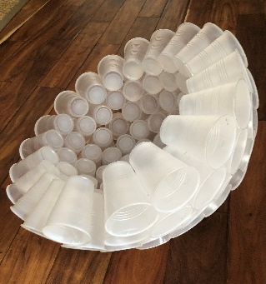

**Questions?** Please email [julia.gorodetsky@kidsindesign.com](mailto:julia.gorodetsky@kidsindesign.com)NOTE: The class is subject to the minimal student enrolment.